1. **Book DataSet:**

inspect(head(rules_conf)) # consider higher lift value.rather than relying on conf to find frequent items

lhs rhs support confidence coverage lift count

[1] {CookBks,

DoItYBks,

ArtBks,

ItalCook} => {ItalArt} 0.0250 0.6849315 0.0365 14.122299 50

With lift value as 14 ( above 1 so it means that these items are popular and relevant ) and brought together .

We cant rely on confidence because it just relies on one transaction item popularity and ignores the other.

rules_conf <- sort (brules, by="lift", decreasing=TRUE)

# 'high-confidence' rules.

inspect(head(rules_conf)) # consider higher lift value.rather than relying on conf to find frequent items

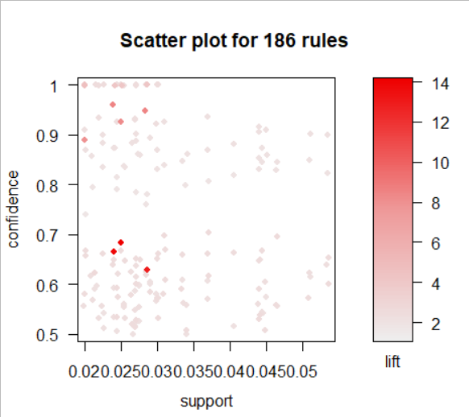

After plotting the grouping the dataset we have inferences like:

1. Cookbooks ,Doit, Art,italCook are most purchased data based on its higher lift values.

2. Transaction with the above dataset also buy ItalArt ..It is related to other transaction above.

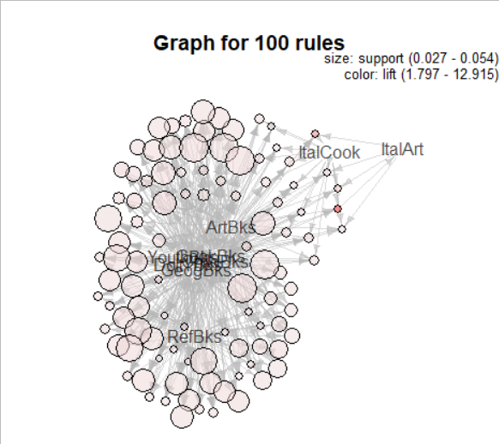

1. **Groceries DataSet:**

Inference:

#most frequent items:

# whole milk other vegetables rolls/buns soda yogurt (Other)

#2513 1903 1809 1715 1372 34055

* Berries are most often brought along with whipped crream/sour cream due to its higher lift value.
* Other vegetable are found most frequently in transaction along with whole milk.

lhs rhs support confidence coverage lift count

[1] {other vegetables} => {whole milk} 0.07483477 0.3867578 0.1934926 1.513634 736

[2] {whole milk} => {other vegetables} 0.07483477 0.2928770 0.2555160 1.513634 736

[3] {rolls/buns} => {whole milk} 0.05663447 0.3079049 0.1839349 1.205032 557

[4] {whole milk} => {rolls/buns} 0.05663447 0.2216474 0.2555160 1.205032 557

[5] {yogurt} => {whole milk} 0.05602440 0.4016035 0.1395018 1.571735 551

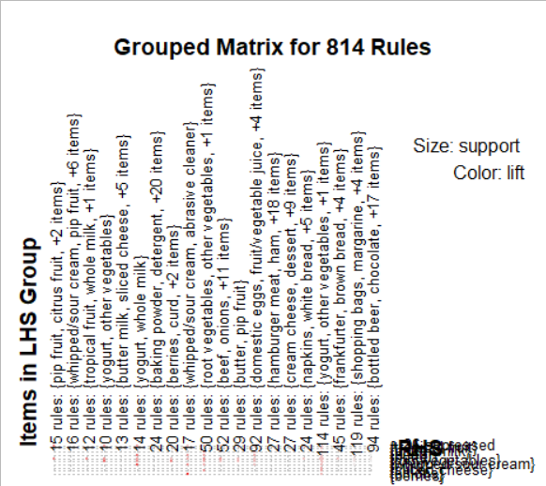

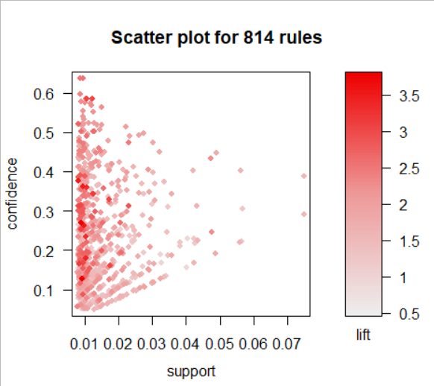

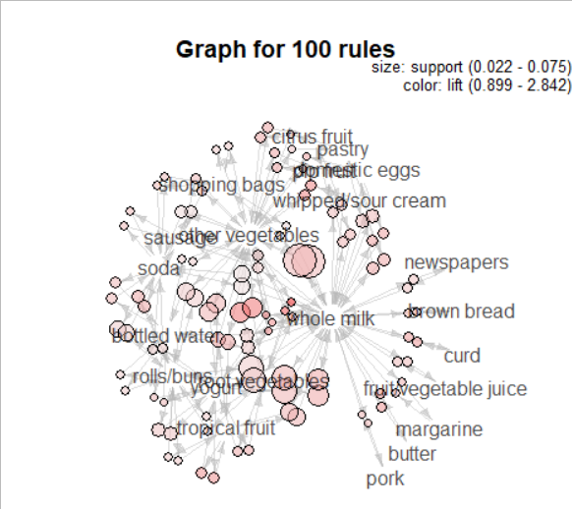

1. **myMovies Data set:**

* Observation on my_movies shows that while giving support =20% and conf =50% we get LOTR1 watchers are recommended to watch LOTR2. GreenMile along with Sixth Sense with higher Lift value .i.e those are popular and mostly brought together.
* LOTR is recommended most due its number of transactions present from both 1 and 2 movies.

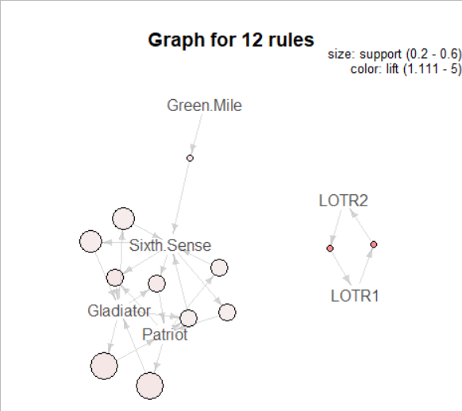

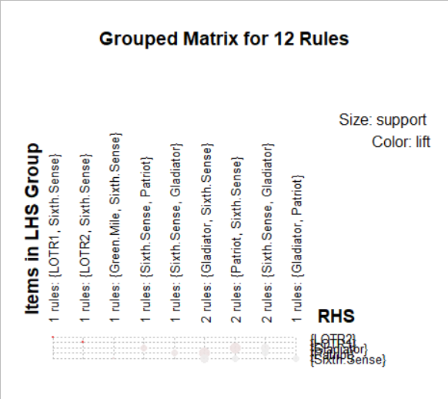

1. MyPhone DataSet Observation:

* Highest lift value is for Red (rhs) and green and white(lhs).
* [1] {white,green} => {red} 0.09090909 1.0000000 0.09090909 1.8333333 1
* Support is highest for blue red white as they are more frequent in binary matrix than other colors.
* lhs rhs support confidence coverage lift count
* [1] {blue} => {red} 0.36363636 0.6666667 0.54545455 1.2222222 4
* [2] {red} => {blue} 0.36363636 0.6666667 0.54545455 1.2222222 4
* [3] {blue} => {white} 0.36363636 0.6666667 0.54545455 1.0476190 4
* [4] {white} => {blue} 0.36363636 0.5714286 0.63636364 1.0476190 4
* [5] {red} => {white} 0.36363636 0.6666667 0.54545455 1.0476190 4

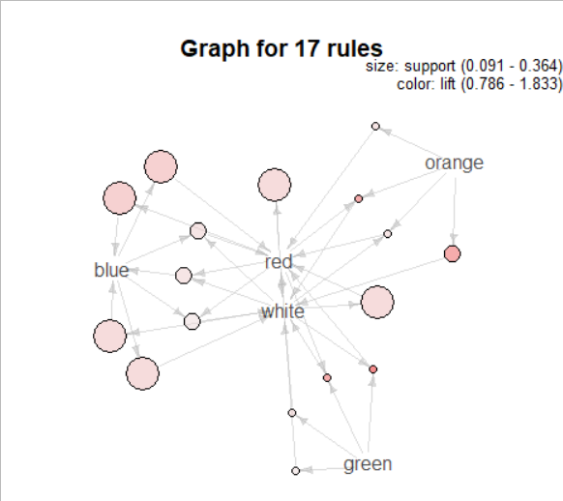

1. Retail Transaction:

* It looks like people who purchase Heart, Holder, T-Light and White would definitely purchase Hanging due to its majority lift value(greater than 1).

People who purchase 72, Cake,Of,Pack would purchase Cases.

